**PROJECT REPORT**

**Credit Risk Analysis**

*Submitted towards the partial fulfillment of the criteria for award of PGA by Imarticus*

*Submitted By:*

*Akshay Prashant Anvekar*

*Karthik Kumar G*

*Course and Batch: PGDA-07 October 2018*



# Abstract

# Acknowledgements

We are using this opportunity to express my gratitude to everyone who supported us throughout the course of this group project. We are thankful for their aspiring guidance, invaluably constructive criticism and friendly advice during the project work. I am sincerely grateful to them for sharing their truthful and illuminating views on a number of issues related to the project.

We wish to thank, all the faculties, as this project utilized knowledge gained from every course that formed the PGA program.

We certify that the work done by us for conceptualizing and completing this project is original and authentic.

Date: April 08, 2019 Akshay Prashant Anvekar

Place: Bangalore Karthik Kumar G

# Certificate of Completion

I hereby certify that the project titled “**Credit Risk Management**” was undertaken and completed under my supervision by Akshay Prashant Anvekar and Karthik Kumar G from the batch of PGDA - 07 (Oct 2018)

Date: April 08, 2019

Place – Bangalore

Table of Contents

Abstract 2

Acknowledgements 2

Certificate of Completion 3

CHAPTER 1: INTRODUCTION 5

1.1 Title & Objective of the study 5

1.2 Need of the Study 5

1.3 Business or Enterprise under study 5

1.4 Business Model of Enterprise 5

1.4 Data Sources 5

1.5 Tools & Techniques 5

1.6 Infrastructure Challenges 6

CHAPTER 2: DATA PREPARATION AND UNDERSTANDING 6

2.1 Phase I – Data Extraction and Cleaning: 6

2.2 Phase II - Feature Engineering 9

2.3 Data Dictionary: 10

2.4 Exploratory Data Analysis: 11

The graph below gives us the state wise allocation of the loan: 14

CHAPTER 3: FITTING MODELS TO DATA 15

4.1 LINEAR REGRESSION MODEL 16

4.1.1 First Linear Regression Model 16

4.1.2 Second Linear Regression model 16

4.1.3 Third Linear Regression model 16

4.2 RANDOM FOREST 17

4.2.1 INFRASTRUCTURE CHALLENGES 17

CHAPTER 5: KEY FINDINGS 17

CHAPTER 6: RECOMMENDATIONS AND CONCLUSION 18

CHAPTER 7: REFERENCES 18

# CHAPTER 1: INTRODUCTION

## Title & Objective of the study

**Credit Risk Analysis:**

We must build a data model to predict the probability of default, and choose a cut-off based on what you feel is suitable. Alternatively, we can also use a modelling technique which gives binary output.

## Need of the Study

The loan proposal will be evaluated using an internal rating system or the credit rating offered by external rating agencies. After the loan sanction the bank needs to follow up and monitor the loan accounts. The loan sanctioned may become a default or a bad loan if the outstanding payments (either interest or installment of the principle amount) are overdue by 90 days. Thus, credit life cycle involves four stages, credit opportunity, credit assessment, credit management and credit implication.

## 1.3 Business or Enterprise under study

In this project we will have to put yourself in the shoes of a loan issuer and manage credit

risk by using the past data and deciding whom to give the loan to in the future. The text files

contain complete loan data for all loans issued by XYZ Corp. through 2007-2015. The data

contains the indicator of default, payment information, credit history, etc.

## 1.4 Business Model of Enterprise

Recognizing the unique challenges in developing fraud models, the ability to be pre-emptive vs. reactive in addressing fraud can yield tremendous benefits. Being pre-emptive with predictive models allows us to take advantage of these benefits. Predictive analytics techniques represent the critical link in crafting preventive fraud strategies. Not only would this methodology save a lot of money, but it will also aim at saving time in the future by identifying fraudulent transactions beforehand.

## 1.4 Data Sources

Imarticus

## 1.5 Tools & Techniques

Tools: Python

Techniques:

Logistic Regression, KNN, Decision Trees, Naïve Bayes, SVM, Gradient Boosting.

## 1.6 Infrastructure Challenges

Due to the large size of the data, the challenges we faced were –

Memory Errors – Not enough RAM

High modelling time – Gradient Boosting took almost 2 hours.

# CHAPTER 2: DATA PREPARATION AND UNDERSTANDING

Our dataset contains a total of 8,55,969 observations in total and contains 73 features.

One of the first steps we engaged in was to outline the sequence of steps that we will be following for our project. Each of these steps are elaborated below.

## 2.1 Phase I – Data Extraction and Cleaning:

* **Missing Value Analysis and Treatment**

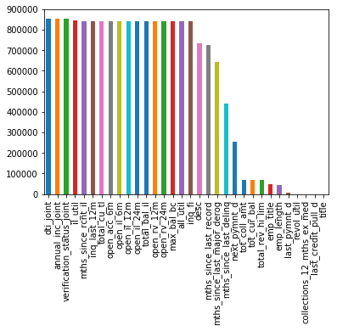

These are the missing values in our data -

dti_joint 855529

annual_inc_joint 855527

verification_status_joint 855527

il_util 844360

mths_since_rcnt_il 843035

inq_last_12m 842681

total_cu_tl 842681

open_acc_6m 842681

open_il_6m 842681

open_il_12m 842681

open_il_24m 842681

total_bal_il 842681

open_rv_12m 842681

open_rv_24m 842681

max_bal_bc 842681

all_util 842681

inq_fi 842681

desc 734157

mths_since_last_record 724785

mths_since_last_major_derog 642830

mths_since_last_delinq 439812

next_pymnt_d 252971

tot_coll_amt 67313

tot_cur_bal 67313

total_rev_hi_lim 67313

emp_title 49443

emp_length 43061

last_pymnt_d 8862

revol_util 446

collections_12_mths_ex_med 56

last_credit_pull_d 50

title 33

All the missing values more than 10% have been removed, and the remaining missing values have been addressed by –

* Numerical by Mean
* Categorical by Mode
* **Handling Outliers**

Check for trends in outliers with the help of box plots**.**

Here are the boxplots of all the quantitative variables from our dataset.

As we are dealing with monetary transactions between accounts, it is in the nature of the variables to have outliers. Since we would be using Logistics Regression as well as tree based models, in which the outliers will have less impact, we decided to keep the outliers but only cap the few outliers which have extremely high values are far away from the majority of the other outliers. We have addressed outliers with the help of IQR where we’ve capped the floor at 5% and ceiling at 95%.

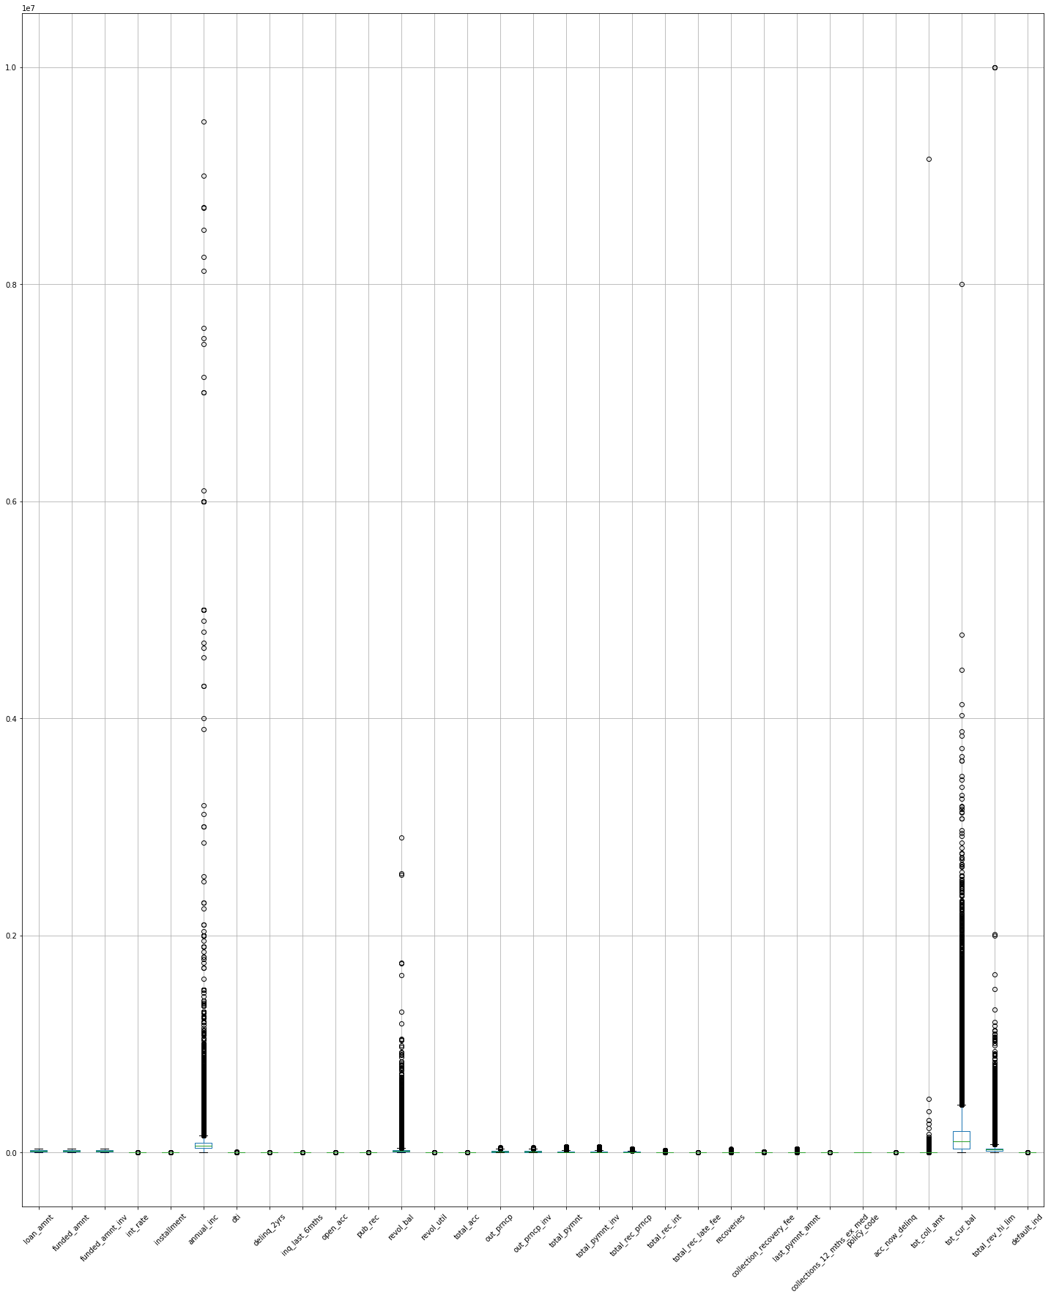

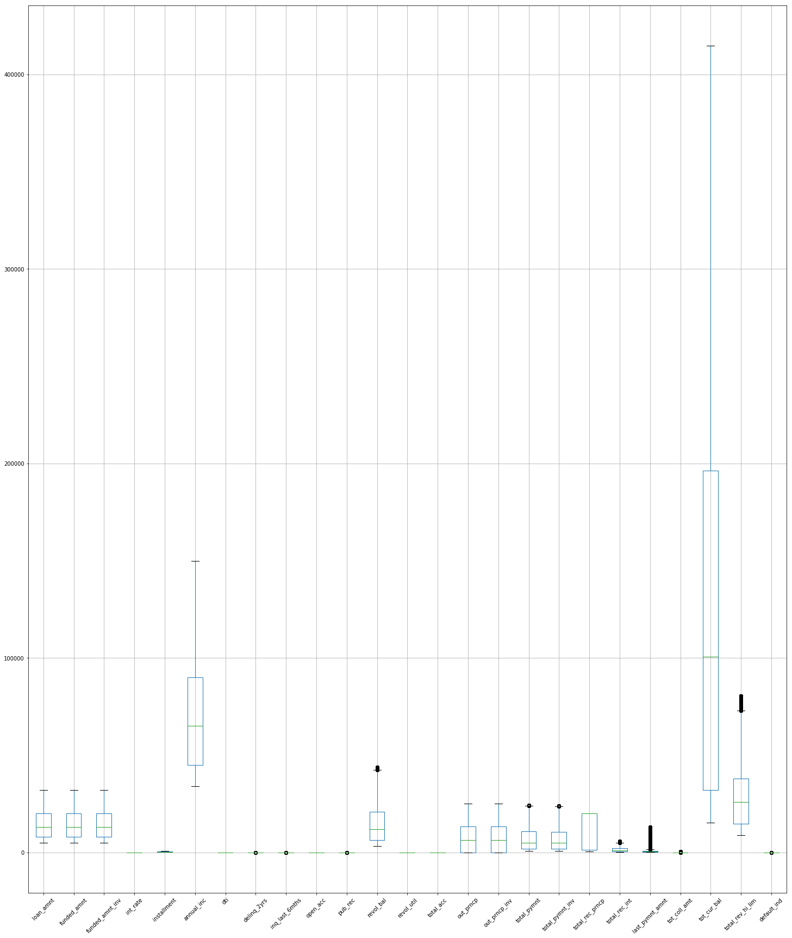

* **Imbalanced dataset –**

Check if the number of observations belonging to one class is significantly higher than those belonging to the other class. In this case, when we plotted a bar graph for the number of observations for each class, we got the following result.

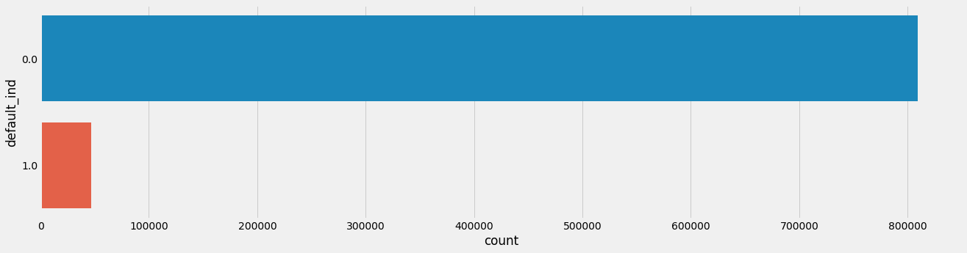

The above graph clearly depicts that our data is highly imbalanced. We will discuss the methods to deal with this after splitting the data into train and test.

## 2.2 Phase II - Feature Engineering

Feature engineering, also known as feature creation, is the process of constructing new

features from existing data to train a machine learning model. A feature is a characteristic that might help when solving the problem. The features in your data are important to the

predictive models you use and will influence the results you are going to achieve. We spent

most of our efforts in feature engineering.

Since we had to split our data based on date as per the problem statement -

The data should be divided into train (June 2007 - May 2015) and out-of-time test (June 2015 - Dec 2015) data.

We converted the feature issue_d to datetime format in Python.

The categorical features were addressed using get_dummies, and numerical features using correlation plot to reduce the number of insignificant features.

## 2.3 Data Dictionary:

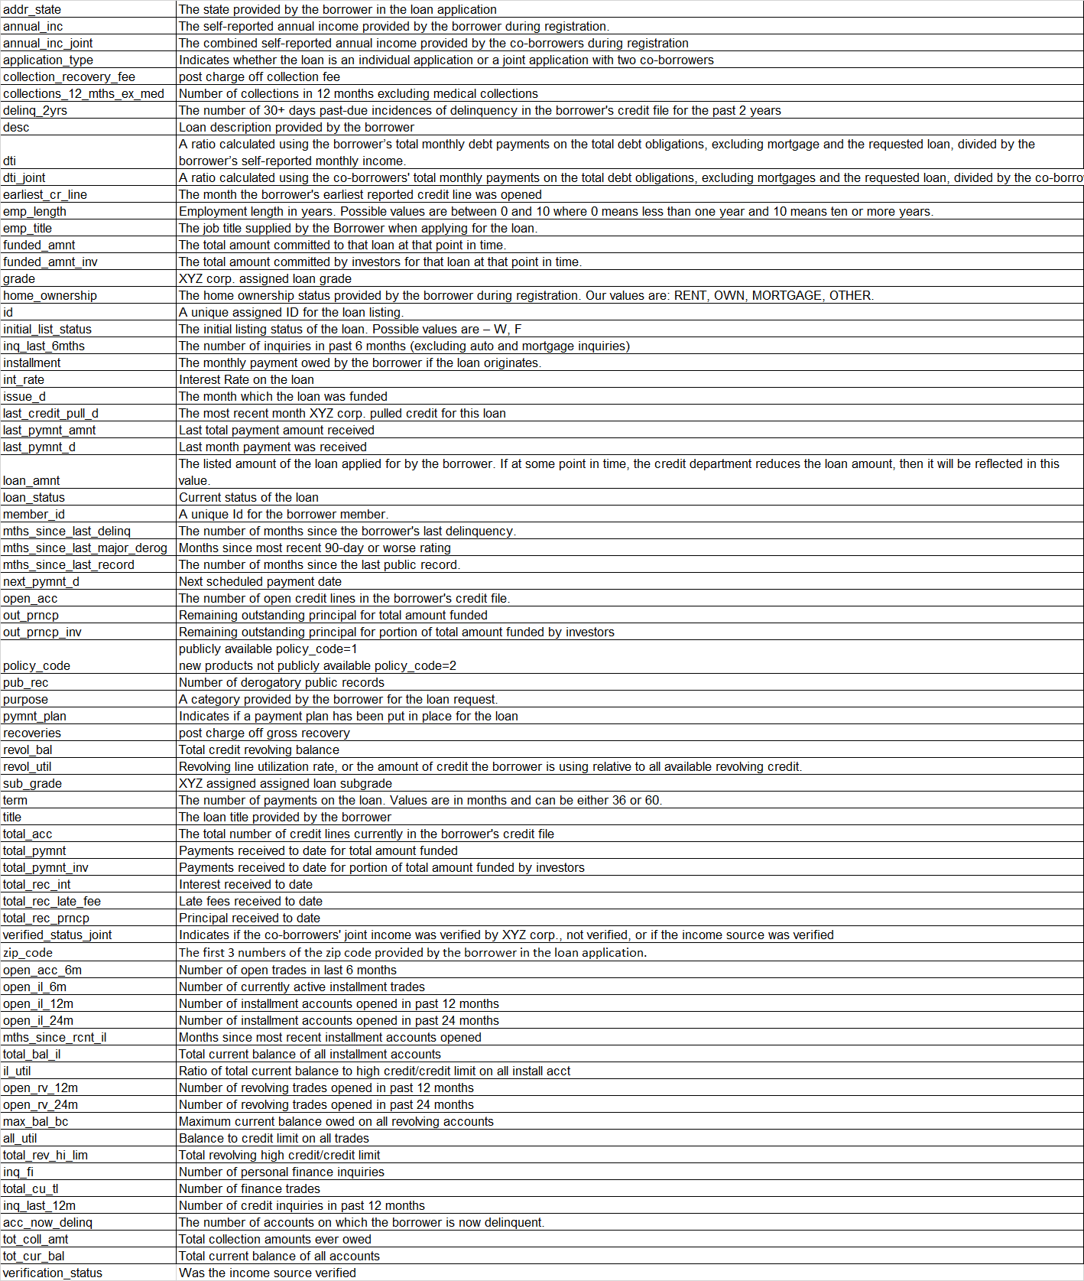

## 2.4 Exploratory Data Analysis:

**Range Index: 855969 entries, 0 to 855968**

**Data columns (total 73 columns):**

**Feature Datatype**

id int64

member_id int64

loan_amnt float64

funded_amnt float64

funded_amnt_inv float64

term object

int_rate float64

installment float64

grade object

sub_grade object

emp_title object

emp_length object

home_ownership object

annual_inc float64

verification_status object

issue_d object

pymnt_plan object

desc object

purpose object

title object

zip_code object

addr_state object

dti float64

delinq_2yrs float64

earliest_cr_line object

inq_last_6mths float64

mths_since_last_delinq float64

mths_since_last_record float64

open_acc float64

pub_rec float64

revol_bal float64

revol_util float64

total_acc float64

initial_list_status object

out_prncp float64

out_prncp_inv float64

total_pymnt float64

total_pymnt_inv float64

total_rec_prncp float64

total_rec_int float64

total_rec_late_fee float64

recoveries float64

collection_recovery_fee float64

last_pymnt_d object

last_pymnt_amnt float64

next_pymnt_d object

last_credit_pull_d object

collections_12_mths_ex_med float64

mths_since_last_major_derog float64

policy_code float64

application_type object

annual_inc_joint float64

dti_joint float64

verification_status_joint object

acc_now_delinq float64

tot_coll_amt float64

tot_cur_bal float64

open_acc_6m float64

open_il_6m float64

open_il_12m float64

open_il_24m float64

mths_since_rcnt_il float64

total_bal_il float64

il_util float64

open_rv_12m float64

open_rv_24m float64

max_bal_bc float64

all_util float64

total_rev_hi_lim float64

inq_fi float64

total_cu_tl float64

inq_last_12m float64

default_ind int64

**dtypes:**

**float64 (49)**

**int64 (3)**

**object (21)**

**TYPE of home ownership:**

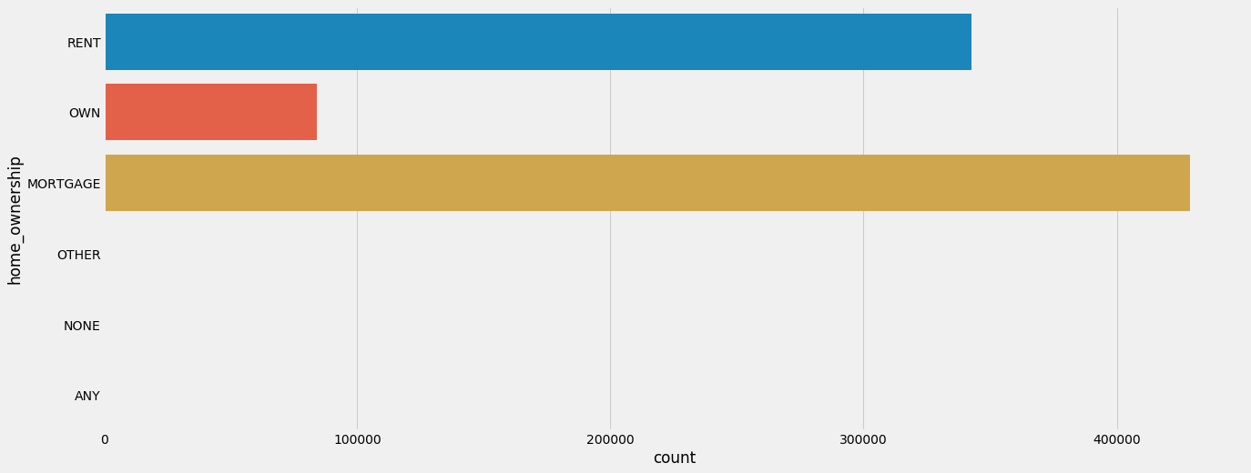

**Checking for correlation between the numeric variables:**

The graph below depicts the multicollinearity between features.

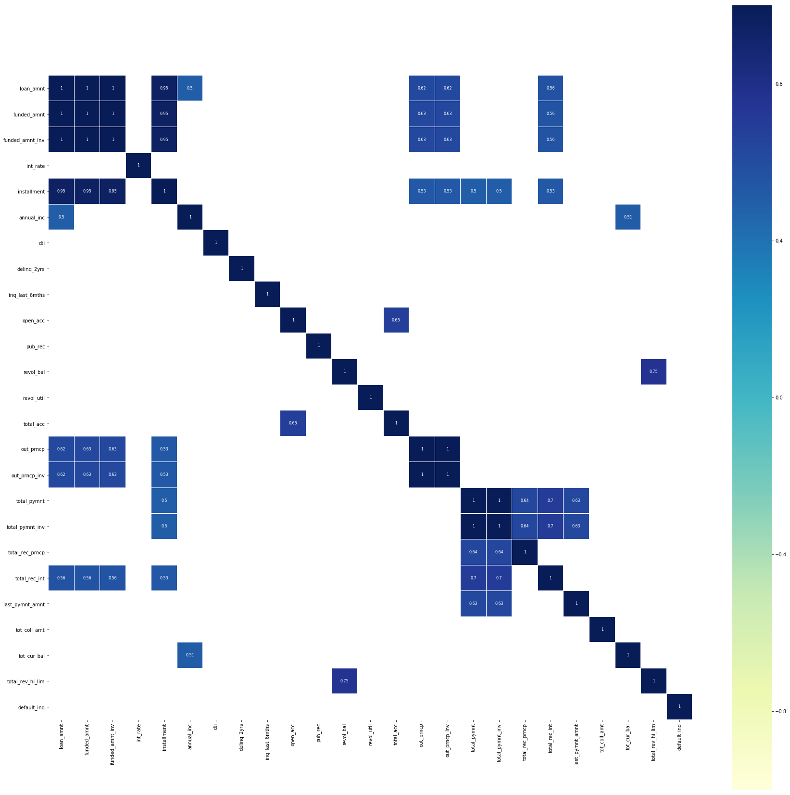

**Term Graph:**

The graph clearly depicts that most of the loans have a term of 36 months.

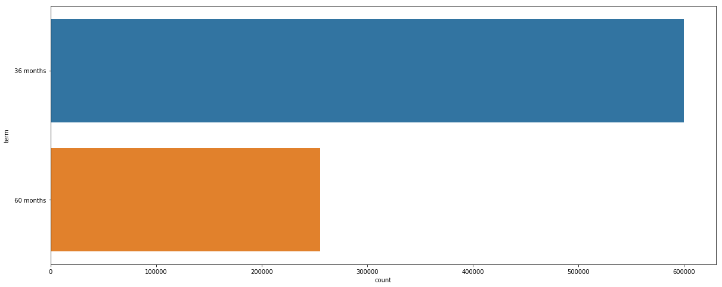

# The graph below gives us the state wise allocation of the loan:

California being the highest.

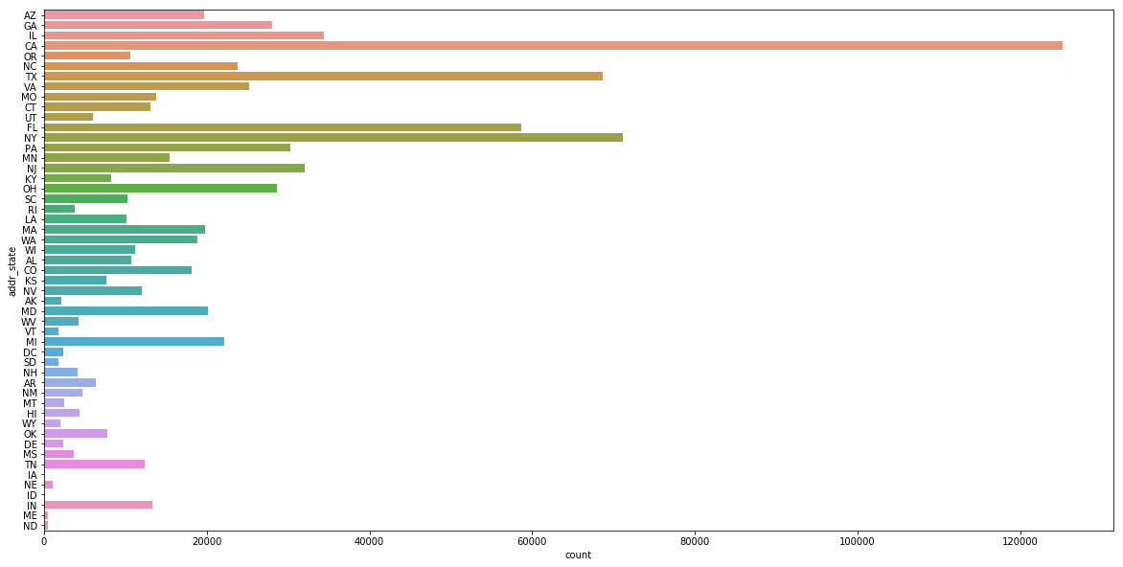

**2.4 Splitting Data:**

As per the given requirement, we are splitting the data based on date.

Our original data contains 855969 observations and 146 features.

After splitting,

train (598978, 145)

train_target (598978, 1)

test (256991, 145)

test_target (256991, 1)

Due to the imbalances in our data,

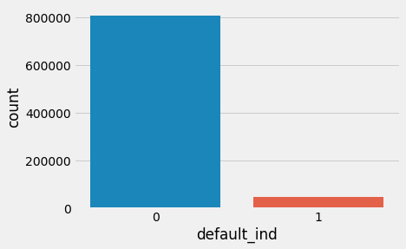

The train data contains:

0 809502

1 46467

For data imbalance problems, mostly handled in three steps.

Over-sample the minority class.

Under-sample the majority class.

Synthesize new minority classes.

SMOTE (Synthetic Minority Over-sampling TEchnique) is coming under the third step. It’s the process of creating a new minority classes from the datasets.

Limitation of SMOTE:

It can only generate examples within the body of available examples—never outside. Formally, SMOTE can only fill in the convex hull of existing minority examples, but not create new exterior regions of minority examples.

To deal with the problem of imbalanced data, we have used SMOTE.

Post which the results are:

After OverSampling, the shape of train_X: (1105644, 144)

After OverSampling, the shape of train_y: (1105644,)

0 552822

1 552822

# CHAPTER 3: FITTING MODELS TO DATA

We have only applied SMOTE on our training data but not on our test subset. The idea was to train the data which includes synthetic observations and use the test set which contains only the original observations to evaluate the accuracy of the model. FYI our test data is also highly imbalanced. As the graph shows,

0.0 256680

1.0 311

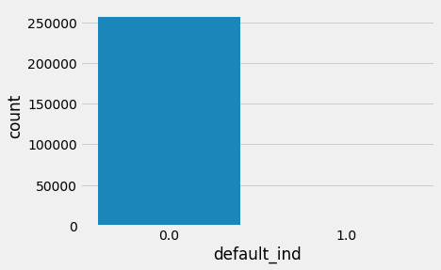

**We will be using different algorithms to fit our model into:**

* **Logistics Regression**
* **KNN**
* **Naïve Bayes**
* **SVC**
* **Decision Tree**
* **Gradient Boosting**

1. **Logistic regression:**

The logistic regression is a predictive analysis which is used to describe data and to explain the relationship between one dependent binary variable, in our case, whether the default indicator is true or not, and one or more nominal, ordinal, interval or ratio-level independent variables.

The results obtained are:

Accuracy: 97.85

Accuracy CV 10-Fold: 96.16

Running Time: 0:05:02.154976

The graph below gives us the ROC-AUC curve for logistic regression.

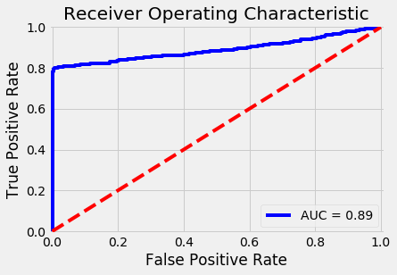

1. **KNN:**

KNN can be used for classification — the output is a class membership (predicts a class — a discrete value). An object is classified by a majority vote of its neighbors, with the object being assigned to the class most common among its k nearest neighbors.

The results obtained are:

Accuracy: 94.27

Accuracy CV 10-Fold: 96.92

Running Time: 0:13:14.751508

The graph below gives us the ROC-AUC curve for KNN.

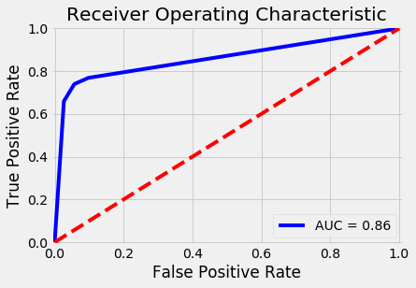

## Naïve Bayes:

Naive Bayes can be extended to real-valued attributes, most commonly by assuming a Gaussian distribution.

This extension of naive Bayes is called Gaussian Naive Bayes. Other functions can be used to estimate the distribution of the data, but the Gaussian (or Normal distribution) is the easiest to work with because you only need to estimate the mean and the standard deviation from your training data.

The results obtained are:

Accuracy: 82.37

Accuracy CV 10-Fold: 84.05

Running Time: 0:01:12.048852

The graph below gives us the ROC-AUC curve for Gaussian Naive Bayes.

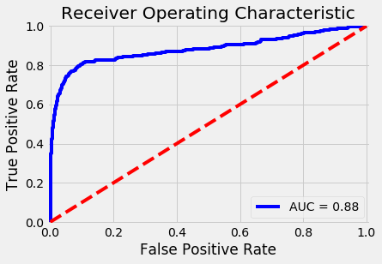

1. **SVM**

A regular SVM with default values uses a radial basis function as the SVM kernel. This is basically a Gaussian kernel aka bell-curve. Meaning that the no man's land between different classes is created with a Gaussian function. The linear-SVM uses a linear kernel for the basis function, so you can think of this as a ^ shaped function. It is much less tunable and is basically just a linear interpolation.

The results obtained are:

Accuracy: 73.39

Accuracy CV 10-Fold: 89.93

Running Time: 0:23:03.089764

1. **Decision Trees:**

A decision tree is a decision support tool that uses a tree-like model of decisions and their possible consequences, including chance event outcomes, resource costs, and utility.

The results obtained are:

Accuracy: 66.79

Accuracy CV 10-Fold: 97.5

Running Time: 0:06:31.606339

The graph below gives us the ROC-AUC curve for Decision Trees.

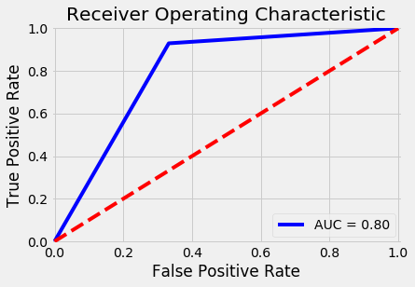

1. **Gradient Boosting Trees:**

**Gradient boosting** is a [machine learning](https://en.wikipedia.org/wiki/Machine_learning) technique for [regression](https://en.wikipedia.org/wiki/Regression_(machine_learning)) and [classification](https://en.wikipedia.org/wiki/Classification_(machine_learning)) problems, which produces a prediction model in the form of an [ensemble](https://en.wikipedia.org/wiki/Ensemble_learning) of weak prediction models, typically [decision trees](https://en.wikipedia.org/wiki/Decision_tree_learning).

The results obtained are:

Accuracy: 91.8

Accuracy CV 10-Fold: 98.36

Running Time: 1:40:13.614813

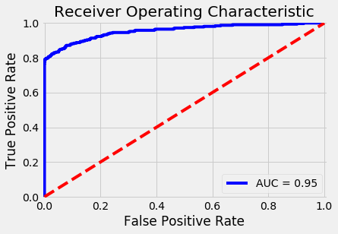

|  |  |
| --- | --- |
| **Model** | **Score** |
| Logistic Regression | 97.85 |
| KNN | 94.27 |
| Gradient Boosting Trees | 91.80 |
| Naive Bayes | 82.37 |
| Linear SVC | 73.39 |
| Decision Tree | 66.79 |
|  |  |

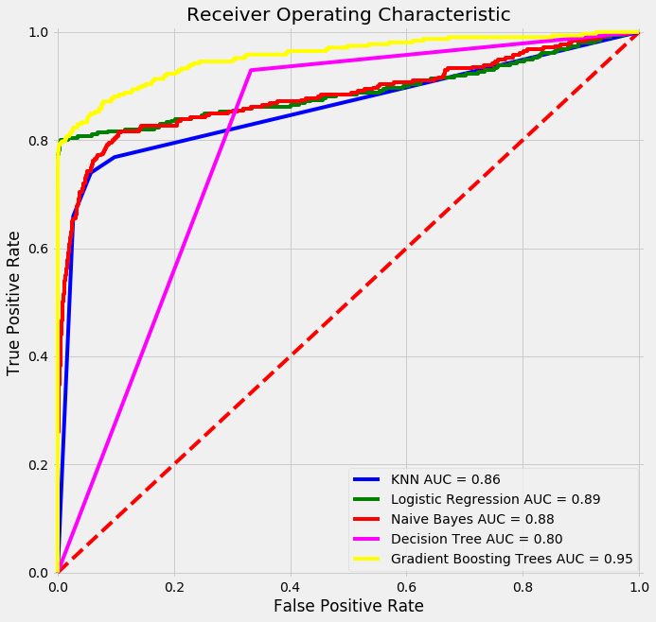

|  |  |
| --- | --- |
| **Model** | **Score** |
| Gradient Boosting Trees | 98.36 |
| Decision Tree | 97.50 |
| KNN | 96.92 |
| Logistic Regression | 96.16 |
| Linear SVC | 89.93 |
| Decision Tree | 84.05 |
|  |  |

CHAPTER 6: RECOMMENDATIONS AND CONCLUSION

* As the total actual defaulters have been predicted properly, the company will end up bearing least loss.
* So the models submitted will lead to better classification as compared to other manual estimations or models.

CHAPTER 7: REFERENCES

* <https://towardsdatascience.com/exploratory-data-analysis-8fc1cb20fd15>
* <https://www.techopedia.com/definition/27752/data-dictionary>
* <https://towardsdatascience.com/detecting-financial-fraud-using-machine-learning-three-ways-of-winning-the-war-against-imbalanced-a03f8815cce9>
* <https://www.kdnuggets.com/2016/12/best-metric-measure-accuracy-classification-models.html>
* <https://medium.com/coinmonks/handling-imbalanced-datasets-predicting-credit-card-fraud-544f5e74e0fd>
* <https://www.kaggle.com/ntnu-testimon/paysim1>
* <https://developers.google.com/machine-learning/crash-course/training-and-test-sets/splitting-data>